Directions: Solve the following absolute value equations and inequalities.

$|2x−5|=1$ $|4−x|=3$ $|3x+3|=9$ $|−2x−1|−2=5$ $|4+x|+3=\text{10}$

$x=$__________ $x=$__________ $x=$__________ $x=$__________ $x=$__________

$2x+4<6$ $−4≥−2x−4>2$ $3(x+1)≥−6$ $2>x+5≥\text{10}$

Solution: __________ Solution: __________ Solution: __________ Solution: __________

Interval Interval Interval Interval
Notation __________ Notation __________ Notation __________ Notation __________

$|x−3|>2$ $|3x|≥−9$ $|−2x−2|≤6$ $|x−1|<−4$

Solution: __________ Solution: __________ Solution: __________ Solution: __________

Interval Interval Interval Interval
Notation __________ Notation __________ Notation __________ Notation __________



Directions: Given the following graphs, write an inequality in slope intercept form.
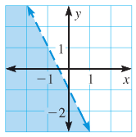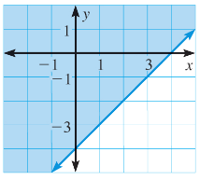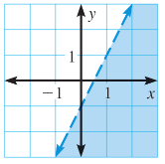

Solution: __________ Solution: __________ Solution: __________

